Exercise I.

Project Summary. Which fruits have you selected? What is your hypothesis regarding which fruit will show higher levels of DNA precipitation? What would be your null hypothesis?

>>This is informal. THINK! What do these fruits have in common? Why these species? Why might one have more than the other?

Paste a photo of each extraction below. Be sure to label which fruit was used.

Fruit 1 _______________________________________ | Fruit 2 _______________________________________

Discuss Your Results. Was your prediction correct? Should you accept your null hypothesis? How could this experiment be improved or made more objective?

Answer the questions below:

- What did the DNA look like? Relate its molecular structure to how it looks when there is a lot of it clumped together.

- Why does dish soap work as a good extraction buffer?

- DNA is soluble in water, but not ethanol. What does this factor have to do with our method of extraction? Explain what happened when the ethanol came in contact with the extraction solution containing your DNA.

- A person cannot see a single cotton thread 100 ft away, but if you wound thousands of threads together into a rope, it would be visible at some distance. How is this statement an analogy to our DNA extraction?

Exercise II.

Label the DNA diagram using the table below
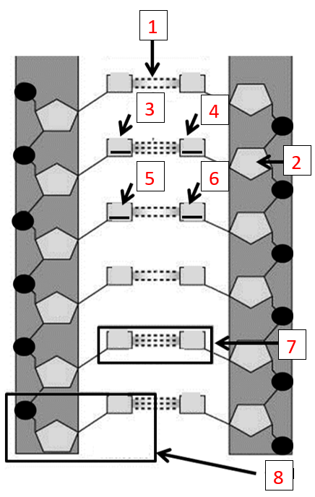

Part | What is it?
1
2
3
4
5
6
7
8

Answer the questions below:

- Explain DNA barcoding in your own words.

- What is our gene of interest (GoI) for this research? Why?

- What do cytochrome b and cytochrome c do? What are they? Where do they exist?

Exercise II.

Copy/paste your DNA Yield Table below.

Exercise III.

Answer the following questions about the virtual lab.

- How many different things are placed in the PCR tube? List each PCR component and what is does.

- List the three steps of PCR and give a one-sentence explanation of what happens in each.

- In this virtual lab, you are asked to add “DNA polymerase” to the PCR tubes. Is this correct? Is it really DNA polymerase? Explain.

- How many cycles of PCR are run in the simulation?

- How many copies are made?

