Paste your DNA calculations table below (up to Lab 11)

Answer the questions about this example gel

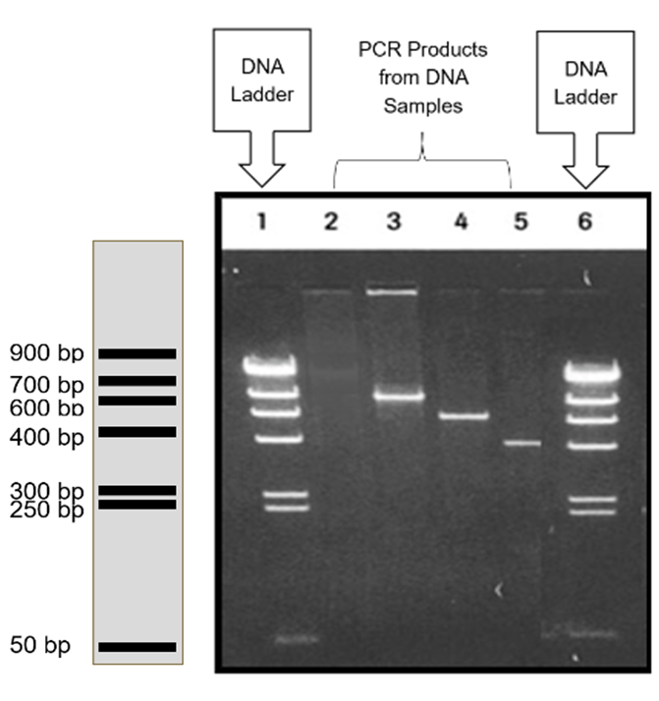

How many different PCR products were tested?

Which one was the longest? How long was it in bp?

Which one was the shortest? How long was it in bp?

Is the positive or negative end of the current at the top of the gel?

Describe what will occur if the person running a Gel Electrophoresis accidentally places the electrodes in the opposite direction as required?

6. Complete the table below.

Fragment | Fragment Size (bp)
2
3
4
5

Answer the questions below about our gel results:

Were all of our samples amplified in PCR? Why or why not?

Did we amplify the right gene? Remember we need a 490bp region of the cytochrome b gene. How do you know?

What did we put in Lane 1? What is it? Why did we include it?

What did we put in Lane 2? What is it? Why did we include it?

What did we put in Lane 3? What is it? Why did we include it?

What did we put in Lanes 4-7?

