Spectrometry

Wavelengths of light are associated with various colors due to their frequency.
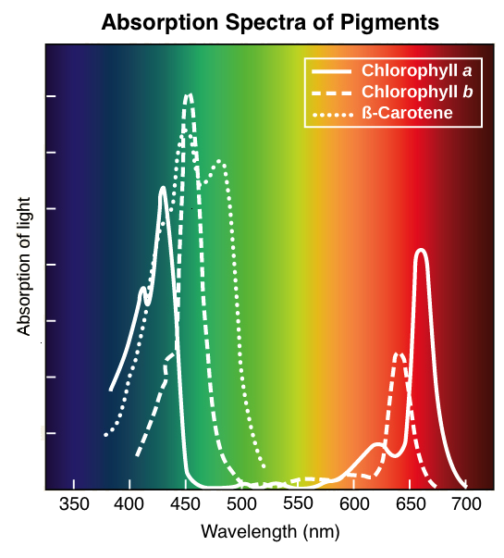
When light hits an object or solution, wavelengths are either absorbed or reflected/transmitted. We see color based on the associated wavelengths that are transmitted (due to transparence) or reflected. We do not see the colors associated with the wavelengths that are absorbed.

For example, view the absorption spectrum for typical plant pigments. The graph shows that when light hits a plant, purple, blue, red, and orange wavelengths have high absorbance values- meaning they are mostly absorbed by the plant and we don not see these colors. Green and yellow wavelengths have low absorbance values- meaning they are reflected... this is what gives plants their green color!

When a color-sensitive indicator is applied to a solution (e.g., Biuret to indicate protein) the absorbance values are directly proportional to the concentration in the solution.
- High Concentration = Dark Color = High Absorbance Values
- Low Concentration = Lighter Color = Low Absorbance Values
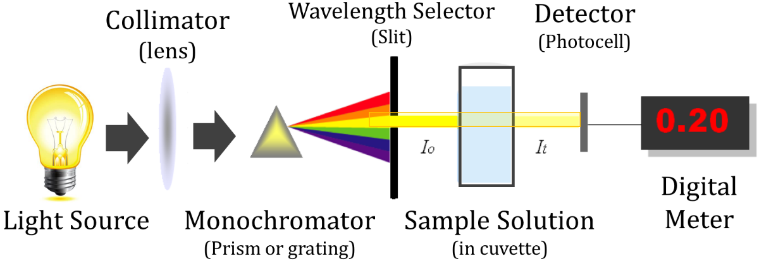
Spectrometers provide the absorbance values for a given sample. By passing a specified wavelength through the sample at a constant distance (see below).

absorbance of light by a substance is directly proportional (linearly related) to its concentration.
Throughout BIOL 121 you will use a Vernier LabQuest 2 and V-spec spectrophotometer to determine the absorption of samples with known and unknown concentrations. By setting up a calibration graph using known concentrations, you can then determine unknown concentrations from absorption (see example below). Throughout this course, you will determine the concentration of unknown samples using absorption.

Calibration graph
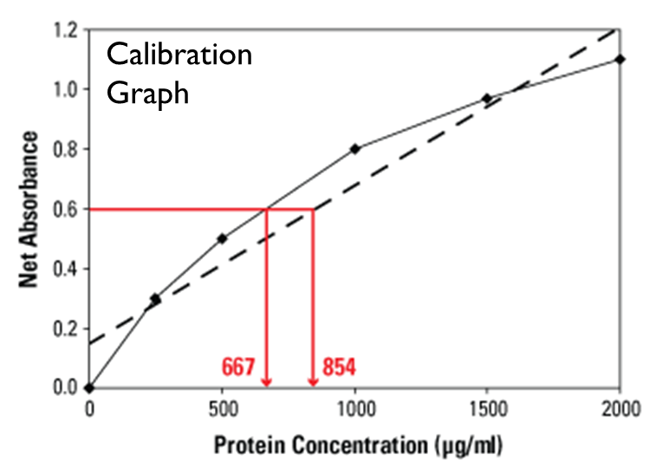

Materials

Spectrometry Instructions

- Power on LabQuest 2.
- Plug in to outlet and spectrophotometer. Wait 15 seconds. It should display an orange/red box with “USB:Abs.” If not, restart.

Calibrate – Must do before each use
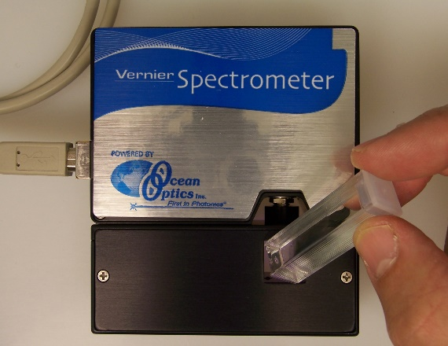
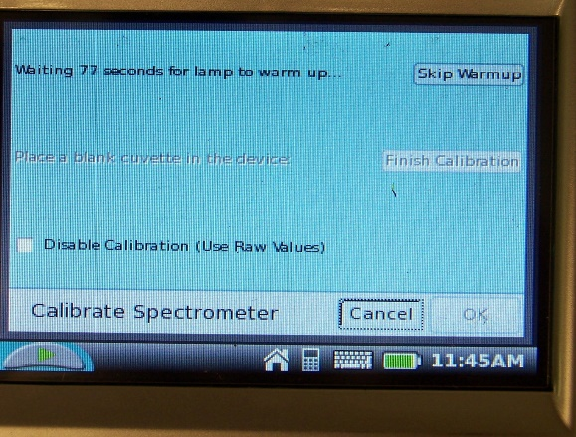
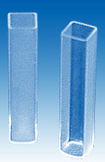
6
2
- Tap orange screen with stylus and click “Calibrate.”

- Wait 90 seconds for lamp to warmup.

- NOTE: Cuvettes are square and have two clear sides and two sides for labeling or gripping the cuvette. The cuvette should always be oriented in the V-Spec so the light passes through the clear sides. Locate the light source in the V-Spec, and ask questions if you are not clear. Always pay attention to this detail.
5

- After warmup, place blank (DI water) cuvette into spectrophotometer. Make sure purple light passes through clear side of cuvette.

- Tap “Finish Calibration” and “OK.”

- Remove blank

Set maximum absorbance – every time!
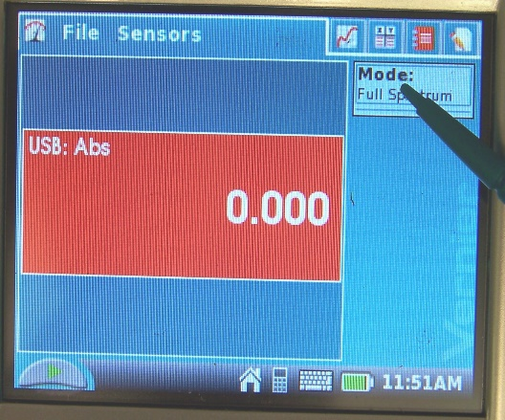
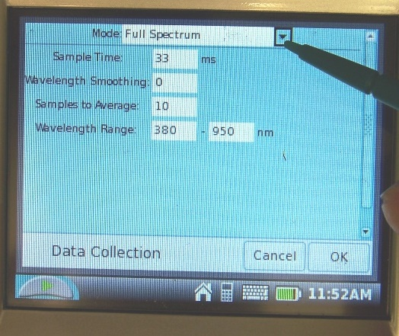
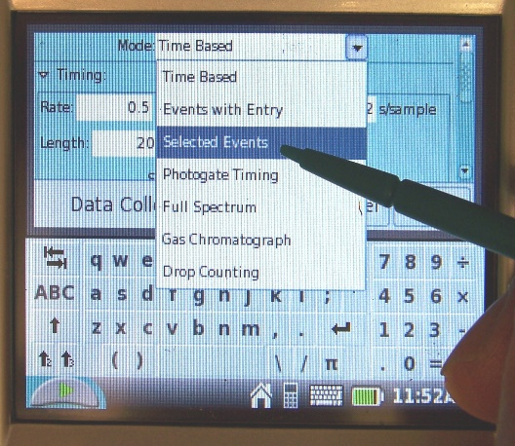
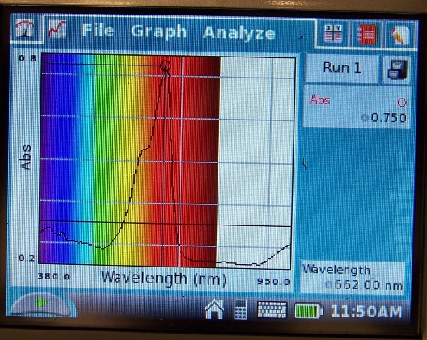
9
16
11
14
- Check “Mode” box to right of screen to make sure it is in “Full Spectrum,” then hit “discard.”

- Place your middle concentration sample (as instructed) into spectrophotometer. Below the orange screen on the LabQuest you will see a green arrow; this is the start/stop button. Tap the start button (green arrow) until the spectrum screen loads and then Tap the same button (now a red square) to stop the scanning of your sample.

- You should now see a complete spectrum of the protein solution and the wavelength of maximum absorbance given at the bottom right corner of the screen.

- Record the “Wavelength” given in the bottom right corner. This is your maximum absorbance. Generally ~660nm. Remove the mid-concentration sample

- To read samples at maximum absorbance, tap the meter symbol at very top left of screen (see left) to return to home screen.

- Tap on “Mode” box on the right of screen

- Tap on dropdown box and choose “Selected Events” “OK” “Discard data.” You will now be able to send the wavelength of maximum absorbance through all the samples to get an equal reading across all protein concentrations.

- The red box should now display your maximum absorbance wavelength and then provide you a number. It is normal for this to be less than zero when no cuvette is there.

Collect absorbance values

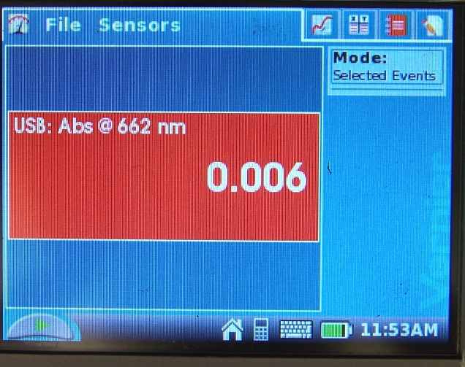
- Place cuvettes into spectrophotometer (light through the clear sides) one at a time.

- Record values

- Shut down: Hold power button

- Discard any data

- Leave plugged in for charging

