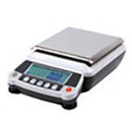

Balance
Used for measuring mass.
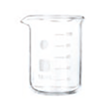

Beaker
Used to hold, mix, and heat liquids.
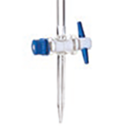

Buret
Used for dispensing an accurate volume of a liquid.
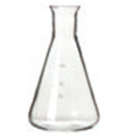

Erlenmeyer Flask
Used to hold and mix chemicals. The small neck is to facilitate mixing without spilling.
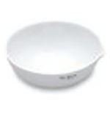

Evaporating Dish
Used to heat liquids for evaporation.
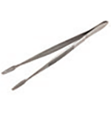

Forceps
Used to pick up or hold small objects.
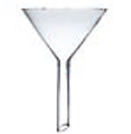

Funnel
Used to transfer liquids or fine-grained materials into containers with small openings. Also used for filtration.
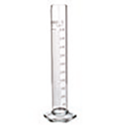

Graduated Cylinder
Used to measure a precise volume of a liquid.
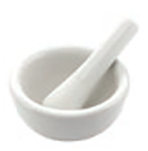

Mortar and Pestle
Used to crush and grind materials.
Used to draw liquids into a pipe.
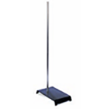

Ring Stand
Used to hold or clamp laboratory glassware and other equipment in place, so it does not fall down or come apart.

Scoopula
Used to transfer solids.

Stirring Rod
Used for stirring and mixing.
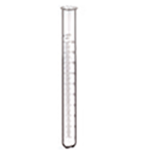

Test Tube
Used to hold and mix liquids.
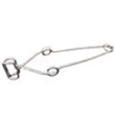

Test Tube Clamp
Used to hold a test tube, particularly when hot.
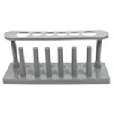

Test Tube Rack
Used to hold several test tubes at one time.
Thermometer (digital or alcohol, not mercury)
Used to measure temperature in Celsius.

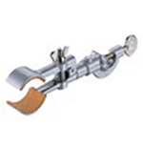

Utility Clamp
Used to secure glassware to a ring stand.
.
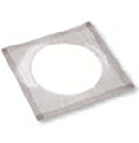

Wire Gauze
Used to support a container, such as a beaker, on a ring stand while it is being heated. May have a fiberglass or ceramic center.

