Spectrometry Instructions

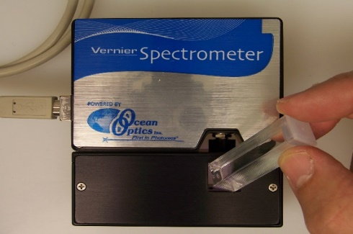
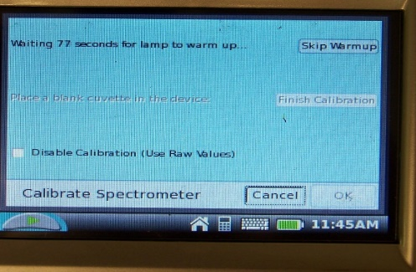
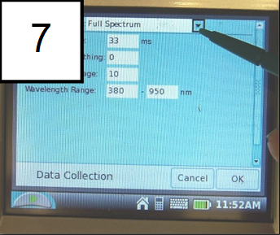
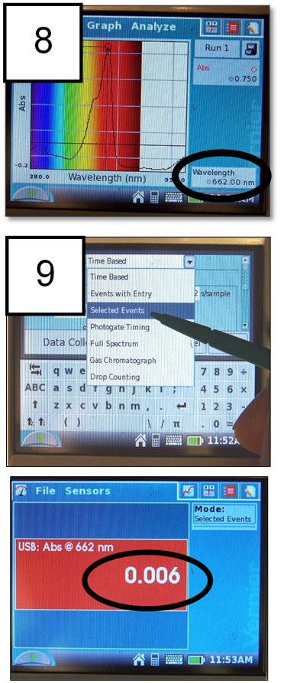
- Power on LabQuest 2.
6
2
- Plug in to outlet and spectrophotometer. Wait 15 seconds. It should display an orange/red box with “USB:Abs.” If not, restart.

Calibrate – Must do before each use
- Tap orange screen with stylus and click “Calibrate.”
- Wait 90 seconds for lamp to warmup.
- NOTE: Cuvettes are square and have two clear sides and two sides for labeling or gripping the cuvette. The cuvette should always be oriented in the V-Spec so the light passes through the clear sides. Locate the light source in the V-Spec, and ask questions if you are not clear. Always pay attention to this detail.
- After warmup, place blank (DI water) cuvette into spectrophotometer. Make sure purple light passes through clear side of cuvette.
- Tap “Finish Calibration” and “OK.”
- Remove blank
- Check the Mode” box and chose to set your wavelength value. Record it in your notes for reference.
- Follow your instructor’s guidance on what value to use. Be sure it shows up in the lower right hand corner.
- Tap on dropdown box and choose “Selected Events” “OK” “Discard data.” You will now be able to send the wavelength of maximum absorbance through all the samples to get an equal reading across all protein concentrations.
- The red box should now display your maximum absorbance wavelength and then provide you a number. It is normal for this to be less than zero when no cuvette is there.

Collect absorbance values

- Place cuvettes into spectrophotometer (light through the clear sides) one at a time.
- Record values
- Shut down: Hold power button

